**Morisita’s Index = CD**

Measure of overlap among samples

= 0 no overlap

= 1 complete overlap with same proportions

uses Simpson in calculations

assumptions: 1) increasing size of samples increases diversity because new habitat sampled

**Modified Raup-Crick = βRC**

-1 = more shared species than expected

1 = less shared species than expected

species present at each site are drawn with probability proportional to its among-site occupancy. Sum number of random draws where Obs > Exp, add ½ sum Obs = Exp and scale between -1 and 1.

RESULTS:

MEADOW ATTRIBUTES

Shoot density increases +0.27 shoots/km moving towards Ocean

LAI increase +240.73 cm2/km moving towards Ocean

Both metics increased over summer at fresher sites

Epiphyte identity and load was variable

Plot abundance started same among all plots, increased in seaward plots through summer (mostly small size fractions)

DIVERSITY

Raw alpha varied as much within as among meadows (higher at RP, BI) mid-July only?

Simpson and Shannon the same?

Seagrass metrics did not explain diversity patterns.

Beta varied varied within meadows, but generally decreased in each meadow from beginning of summer to end, both by gamma/mean alpha and mean Bray-Curtis dissimilarity methods. Mid-summer increase in beta was magnified as measured by Bray-Curtis and inverse patter of beta seen at RP (mid summer low per gamma/mean alpha)

RAUP-CRICK

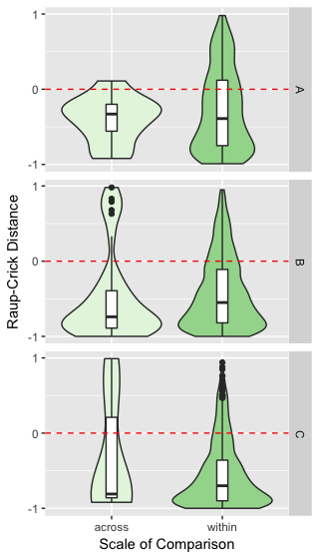TIME A – MEDIAN: across = -0.33, within = -0.39

MEAN: across = -0.40, within -0.28

RANGE: across = -0.92:0.11 , within = -0.99:0.98

TIME B – MEDIAN: across = -0.74, within = -0.55

MEAN: across = -0.48, within = -0.43

RANGE: across = -1.00:0.98 , within = -1.00:0.95

TIME C – MEDIAN: across = -0.81, within = -0.70

MEAN: across = -0.35, within = -0.56

RANGE: across = -0.92:0.99 , within = -1.00:0.94

Raup-Crick measure generally decreased (plots/sites became more similar) from beginning to end of summer. More variation within sites than across at beginning of summer, that pattern reversed by end of summer.

MORISITA

TIME B – MEDIAN: 0.46

MEAN: 0.44

RANGE: 0.03:0.69